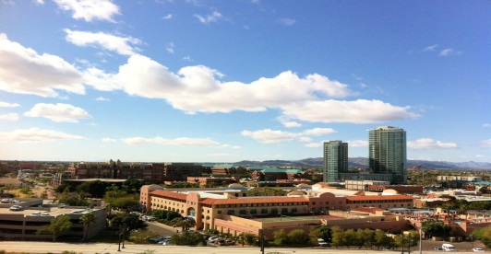

Departure to the Airport From Tempe Mission Palms

Shuttle service is available between 5:30am and 10:00pm:
It is still recommended that individuals arrive at the airport 1 ½ to 2 hours prior to departure time. Please take that into consideration when deciding when to leave the hotel.

The shuttle leaves on the hour and the half hour. Please be down in the front lobby near the Bell desk 10 minutes prior to shuttle departure. Let a Bellman know you are taking the next shuttle.

Guests will be taken to the airport on a space available basis. We do not take reservations.

